FUSION ENGINEERING AND DESIGN

2nd IAEA Technical Committee Meeting on Control Data Acquisition and Remote Participation on Fusion Research

How to Estimate Paper Length

Reliable and simple calculation of the number of printed pages (pp) of a manuscript consisting of text, tables and figures.

Assumption: the manuscript is printed in the journal as a two-column article of 48 lines per column, i.e. one pp full text contains 2 x 48 x 48 = 4608 characters (spaces included).

Step 1: Calculation of number of pp pure text
1. Estimate the average number of characters of a full line of your manuscript (spaces included) - .......... (a)
2. Count the number of lines pure text, i.e. excluding title affiliations, abstract, tables and figure captions (NB: around section headings allow 2 lines extra) - .......... (b)
3. (a) x (b) - .......... (c)
4. Number of pp pure text is: (c) /4608 - .......... pp (A)

Step 2: Estimation of space for title, affiliations and abstract
(i) Short title + few authors + small abstract - 0.25 pp;
(ii) normal - 0.5 pp;
(iii) long title + many authors + long abstract - 0.75 pp;
Estimate .......... pp (B)

Step 3: Estimation of total space for tables and figures
The best you can do is to indicate on each figure or table what size (in pp) it should be printed in the journal.

You can choose:
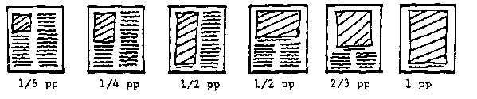
Total space estimated for figures and tables - .......... pp (C).

Now total number of printed pages of the manuscript is:
(A) + (B) + (c) - .......... printed pages

