Title of the contribution prepared
(Times 14, bold, centred)

First AuthorP^{1P}, Presenting AuthorU1^{2P}, Corresponding Author ^{(*)1P}, Last AuthorP^{3P}
(Times 12, centred)

¹ Instituto Superior Técnico, Universidade de Lisboa, 1049-001 Lisboa, Portugal
² Faculdade de Engenharia da Universidade do Porto, 4200-465 Porto, Portugal
³ Departamento de Física, Universidade da Madeira, 9000 Funchal, Portugal
(times 10, italic, centred)

^{(*)} email of corresponding author

All interested participants are invited to present the latest results of their scientific work in “The plasma road to sustainable chemical conversion” workshop in Madeira. The deadline for abstract submission is May 1, 2023. However, early submission is encouraged.
Abstracts must be written in English. The authors are responsible for both the content and style of their contributions. No editing or re-typing will be carried out by the conference organizers, and accepted contributions will be reproduced without reduction or modification. Contributions that do not conform to the format of the template may be rejected.
Each contributed abstract must be submitted as pdf file. A docx template file is available for download. In order to have an abstract accepted, at least one of the authors must have paid the registration fee by the regular registration deadline: May 30, 2023.
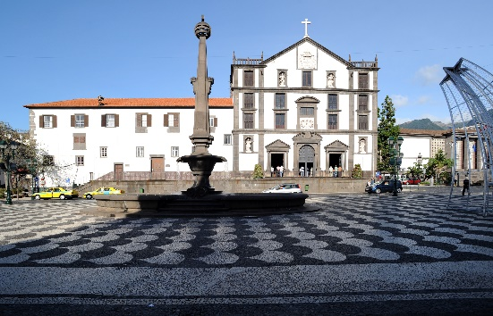
Fig. 1: Captions should be Times New Roman, 10 pt. Note that figures can be embedded in the text.
Abstracts should be in single column A4 layout, and have only 1 page.
Item | Format (using Times New Roman font):
Title | Bold, centred, 14 pt
Author names | Normal, centred, 12 pt
Affiliations | Italic, centred, 10 pt
Main text | Normal, justified (left and right, use hyphenation), 11pt, A4 portrait

Place references at the end of the paper, and cite using a numerical scheme [1]:
References
[1] A. N. Other, J. Defined Ambiguity, 22 (2018) 37-47

